Ex1G1

Using the debugger, answer the following questions assuming that the user enters the following values and clicks button1:

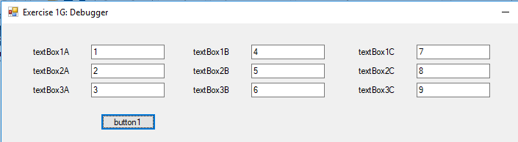

**Question 1**(1 point)

Before executing statement #1, the value of textBox1A.Text is

Question 1 options:

|  |  |
| --- | --- |
|  | 1 |
|  | "1" |
|  | 4 |
|  | "4" |

Save

**Question 2**(1 point)

After executing statement #1, the value of textBox1A.Text is

Question 2 options:

|  |  |
| --- | --- |
|  | 1 |
|  | "1" |
|  | 4 |
|  | "4" |

Save

**Question 3**(1 point)

After executing statement #1, the value of textBox1C.Text is

Question 3 options:

|  |  |
| --- | --- |
|  | 5 |
|  | "5" |
|  | 14 |
|  | "14" |

Save

**Question 4**(1 point)

Before executing statement #2, the value of textBox2C.Text is

Question 4 options:

|  |  |
| --- | --- |
|  | "7" |
|  | "2" |
|  | "5" |
|  | "8" |

Save

**Question 5**(1 point)

After executing statement #2, the value of textBox2C.Text is

Question 5 options:

|  |  |
| --- | --- |
|  | "7" |
|  | "2" |
|  | "5" |
|  | "8" |

Save

**Question 6**(1 point)

Before executing statement #3, the value of textBox3C.Text is

Question 6 options:

|  |  |
| --- | --- |
|  | "3" |
|  | "6" |
|  | "9" |
|  | "36" |

Save

**Question 7**(1 point)

After executing statement #3, the value of textBox3C.Text is

Question 7 options:

|  |  |
| --- | --- |
|  | "3" |
|  | "6" |
|  | "9" |
|  | "36" |

Save

**Question 8**(1 point)

Before executing statement #4, the value of textBox1A.Text is

Question 8 options:

|  |  |
| --- | --- |
|  | "414" |
|  | "14" |
|  | "4" |
|  | "1" |

Save

**Question 9**(1 point)

After executing statement #4, the value of textBox1A.Text is

Question 9 options:

|  |  |
| --- | --- |
|  | "414" |
|  | "14" |
|  | "4" |
|  | "1" |

Save

**Question 10**(1 point)

Before executing statement #5, the value of textBox2A.Text is

Question 10 options:

|  |  |
| --- | --- |
|  | "1" |
|  | "2" |
|  | "57" |
|  | "5" |

Save

**Question 11**(1 point)

After executing statement #5, the value of textBox2A.Text is

Question 11 options:

|  |  |
| --- | --- |
|  | "1" |
|  | "2" |
|  | "57" |
|  | "5" |

Save

**Question 12**(1 point)

Before executing statement #6, the value of textBox3B.MaxLength is

Question 12 options:

|  |  |
| --- | --- |
|  | 0 |
|  | "1" |
|  | 32767 |
|  | "32767" |

Save

**Question 13**(1 point)

After executing statement #6, the value of textBox3B.MaxLength is

Question 13 options:

|  |  |
| --- | --- |
|  | 0 |
|  | "1" |
|  | 32767 |
|  | "32767" |

Save

**Question 14**(1 point)

Before executing statement #6, the value of textBox3C.SelectionLength is

Question 14 options:

|  |  |
| --- | --- |
|  | 0 |
|  | "1" |
|  | 32767 |
|  | "32767" |

Save

**Question 15**(1 point)

Before executing statement #6, the value of textBox3A.Text is

Question 15 options:

|  |  |
| --- | --- |
|  | 3 |
|  | "3" |
|  | 32767 |
|  | "32767" |

Save

**Question 16**(1 point)

After executing statement #6, the value of textBox3A.Text is

Question 16 options:

|  |  |
| --- | --- |
|  | 3 |
|  | "3" |
|  | 32767 |
|  | "32767" |

Save

**Question 17**(1 point)

Before executing statement #7, the value of textBox1B.Text is

Question 17 options:

|  |  |
| --- | --- |
|  | "400.00" |
|  | "4.00" |
|  | "4" |
|  | "414" |

Save

**Question 18**(1 point)

Before executing statement #8, the value of textBox2B.Text is

Question 18 options:

|  |  |
| --- | --- |
|  | "5.00" |
|  | "5" |
|  | "14" |
|  | "414" |

Save

**Question 19**(1 point)

After executing statement #8, the value of textBox2B.Text is

Question 19 options:

|  |  |
| --- | --- |
|  | "5796" |
|  | "5,796.00" |
|  | "5796.00" |
|  | "414" |

Save

**Question 20**(1 point)

QuestionBefore executing statement #9, the value of textBox3B.Text is

Question 20 options:

|  |  |
| --- | --- |
|  | "32767" |
|  | "36" |
|  | "6" |
|  | "910.19" |

Save

**Question 21**(1 point)

QuestionAfter executing statement #9, the value of textBox3B.Text is

Question 21 options:

|  |  |
| --- | --- |
|  | "32767" |
|  | "36" |
|  | "6" |
|  | "910.19" |

Save

Ex1G2

Given the user input in each question, determine which input value causes an exception to be thrown.

**Question 22**(1 point)

The user enters the following input:

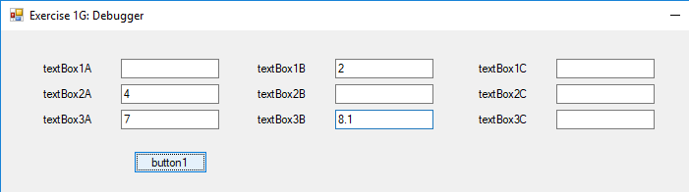

Which input value causes the exception to be thrown?

Question 22 options:

|  |  |
| --- | --- |
|  | textBox1A.Text |
|  | textBox1B.Text |
|  | textBox2A.Text |
|  | textBox2B.Text |

Save

**Question 23**(1 point)

The user enters the following input:

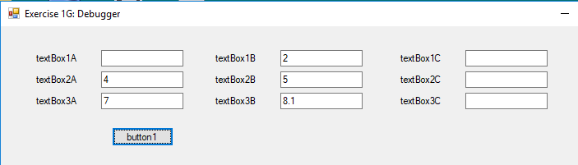

Which input value causes the exception to be thrown?

Question 23 options:

|  |  |
| --- | --- |
|  | textBox3A.Text |
|  | textBox3B.Text |
|  | textBox2A.Text |
|  | textBox2B.Text |

Save

**Question 24**(1 point)

The user enters the following input:



Which input value causes the exception to be thrown?

Question 24 options:

|  |  |
| --- | --- |
|  | textBox3A.Text |
|  | textBox3B.Text |
|  | textBox2A.Text |
|  | textBox2B.Text |

Save

**Question 25**(1 point)

The user enters the following input:

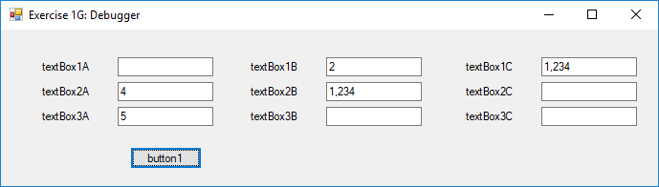

Which input value causes the exception to be thrown?

Question 25 options:

|  |  |
| --- | --- |
|  | textBox3A.Text |
|  | textBox3B.Text |
|  | textBox2A.Text |
|  | textBox2B.Text |

Save

Ex1G3

If the program is paused at the given location, determine the value of the expression.

**Question 26**(1 point)

The user enters the following input:



What value will the following expression have immediately before statement #9 is executed:

textBox2B.Text

Question 26 options:

|  |  |
| --- | --- |
|  | "5,796.00" |
|  | 5796 |
|  | "5" |
|  | 5 |

Save

**Question 27**(1 point)

The user enters the following input:



What value will the following expression have immediately before statement #9 is executed:

Convert.ToDecimal(textBox3A.Text)

Question 27 options:

|  |  |
| --- | --- |
|  | "32767" |
|  | 32767 |
|  | "5" |
|  | 5 |

Save

**Question 28**(1 point)

The user enters the following input:



What value will the following expression have immediately before statement #9 is executed:

Convert.ToDecimal(textBox3A.Text) / Convert.ToDecimal(textBox3C.Text)

Question 28 options:

|  |  |
| --- | --- |
|  | 910.19444444... |
|  | "910.19444444..." |
|  | 910.19 |
|  | "910.19" |

Save